**SPRING REST USING SPRING BOOT 3**

# **HANDS ON-1 =>  Create a Spring Web Project using Maven**

**SpringLearnApplication.java**

package com.cognizant.springlearn;

import org.springframework.boot.SpringApplication;

import org.springframework.boot.autoconfigure.SpringBootApplication;

@SpringBootApplication

public class SpringLearnApplication {

public static void main(String[] args) {

SpringApplication.run(SpringLearnApplication.class, args);

System.out.println("SpringLearnApplication main() method is running...");

}

}

**Pom.xml**

<?xml version="1.0" encoding="UTF-8"?>

<project

xmlns="http://maven.apache.org/POM/4.0.0"

xmlns:xsi="http://www.w3.org/2001/XMLSchema-instance"

xsi:schemaLocation="

http://maven.apache.org/POM/4.0.0

https://maven.apache.org/xsd/maven-4.0.0.xsd">

<modelVersion>4.0.0</modelVersion>

<parent>

<groupId>org.springframework.boot</groupId>

<artifactId>spring-boot-starter-parent</artifactId>

<version>3.5.3</version>

<relativePath/> <!-- lookup parent from repository -->

</parent>

<groupId>com.cognizant</groupId>

<artifactId>spring-learn</artifactId>

<version>0.0.1-SNAPSHOT</version>

<name>spring-learn</name>

<description>Demo project for Spring Boot</description>

<properties>

<java.version>17</java.version>

</properties>

<dependencies>

<!-- Spring Web -->

<dependency>

<groupId>org.springframework.boot</groupId>

<artifactId>spring-boot-starter-web</artifactId>

</dependency>

<!-- DevTools (optional, for hot reload) -->

<dependency>

<groupId>org.springframework.boot</groupId>

<artifactId>spring-boot-devtools</artifactId>

<scope>runtime</scope>

<optional>true</optional>

</dependency>

<!-- Testing -->

<dependency>

<groupId>org.springframework.boot</groupId>

<artifactId>spring-boot-starter-test</artifactId>

<scope>test</scope>

</dependency>

</dependencies>

<build>

<plugins>

<!-- Package as executable jar -->

<plugin>

<groupId>org.springframework.boot</groupId>

<artifactId>spring-boot-maven-plugin</artifactId>

</plugin>

</plugins>

</build>

</project>

**Output**

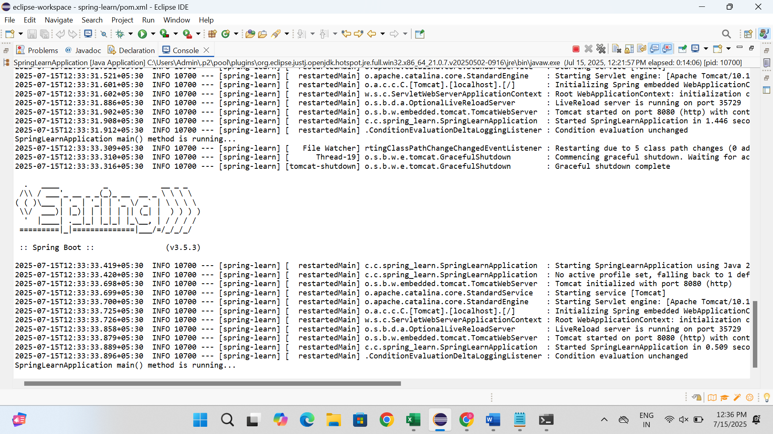

* **Hands ON-2 => Spring Core – Load SimpleDateFormat from Spring Configuration XML**

**SpringLearnApplication.java**

package com.example;

import java.text.ParseException;

import java.text.SimpleDateFormat;

import java.util.Date;

import org.springframework.context.ApplicationContext;

import org.springframework.context.support.ClassPathXmlApplicationContext;

public class SpringLearnApplication {

private static ApplicationContext context;

public static void main(String[] args) {

displayDate();

}

public static void displayDate() {

context = new ClassPathXmlApplicationContext("date-format.xml");

SimpleDateFormat format = context.getBean("dateFormat", SimpleDateFormat.class);

try {

Date date = format.parse("31/12/2018");

System.out.println("Parsed Date: " + date);

} catch (ParseException e) {

e.printStackTrace();

}

}

}

**Pom.xml**<project xmlns="http://maven.apache.org/POM/4.0.0"

xmlns:xsi="http://www.w3.org/2001/XMLSchema-instance"

xsi:schemaLocation="http://maven.apache.org/POM/4.0.0

http://maven.apache.org/xsd/maven-4.0.0.xsd">

<modelVersion>4.0.0</modelVersion>

<groupId>com.example</groupId>

<artifactId>spring-learn</artifactId>

<version>1.0-SNAPSHOT</version>

<dependencies>

<!-- Spring Context for ApplicationContext and ClassPathXmlApplicationContext -->

<dependency>

<groupId>org.springframework</groupId>

<artifactId>spring-context</artifactId>

<version>5.3.30</version> <!-- You can use a stable/latest version -->

</dependency>

</dependencies>

</project>

**Output**

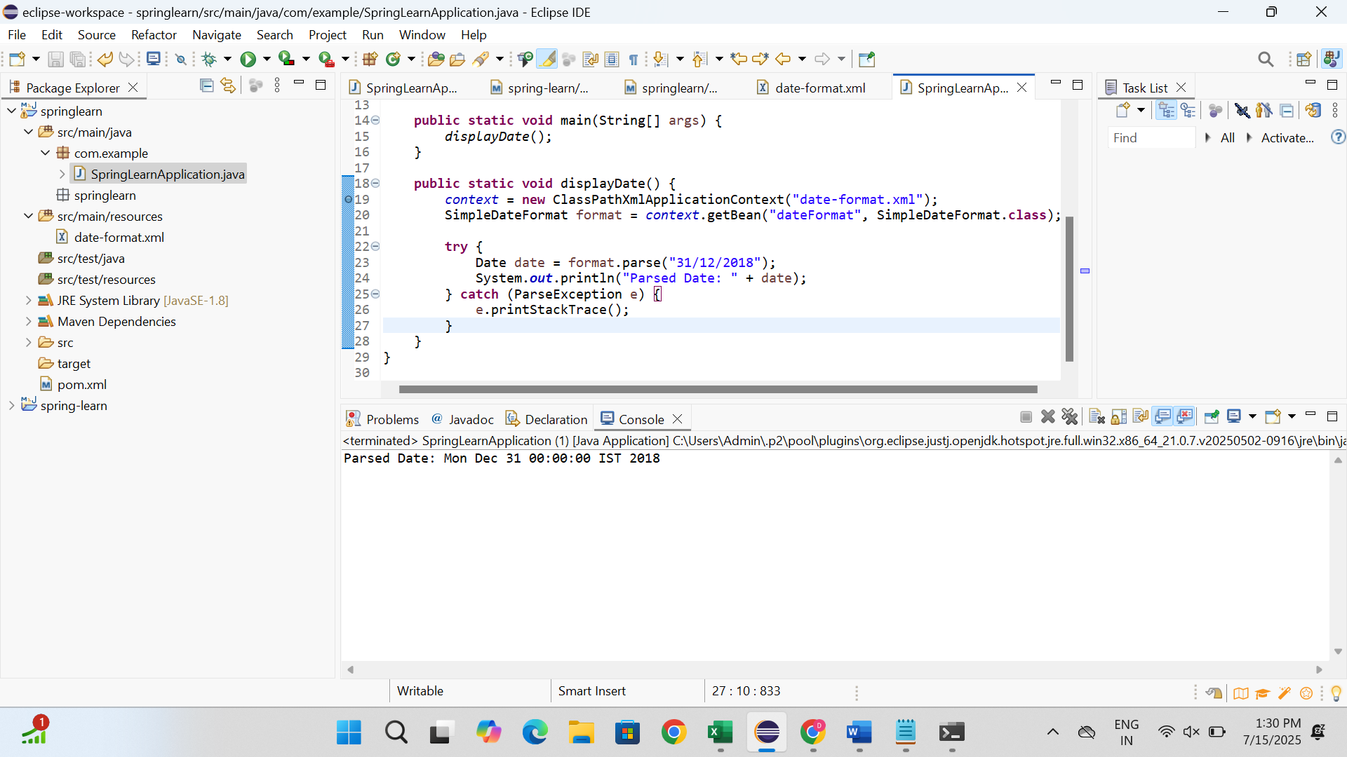

* **Hands on 3 => Spring Core - Incorporate Logging**

**Pom.xml**

<project xmlns="http://maven.apache.org/POM/4.0.0"

xmlns:xsi="http://www.w3.org/2001/XMLSchema-instance"

xsi:schemaLocation="http://maven.apache.org/POM/4.0.0

http://maven.apache.org/xsd/maven-4.0.0.xsd">

<modelVersion>4.0.0</modelVersion>

<groupId>com.example</groupId>

<artifactId>spring-learn</artifactId>

<version>1.0-SNAPSHOT</version>

<properties>

<maven.compiler.source>1.8</maven.compiler.source>

<maven.compiler.target>1.8</maven.compiler.target>

</properties>

<dependencies>

<!-- Spring Core and Context for ApplicationContext and XML Config -->

<dependency>

<groupId>org.springframework</groupId>

<artifactId>spring-context</artifactId>

<version>5.3.30</version>

</dependency>

<!-- SLF4J API (Logger, LoggerFactory) -->

<dependency>

<groupId>org.slf4j</groupId>

<artifactId>slf4j-api</artifactId>

<version>1.7.36</version>

</dependency>

<!-- SLF4J Simple implementation to print logs to console -->

<dependency>

<groupId>org.slf4j</groupId>

<artifactId>slf4j-api</artifactId>

<version>1.7.36</version>

</dependency>

<dependency>

<groupId>ch.qos.logback</groupId>

<artifactId>logback-classic</artifactId>

<version>1.2.11</version>

</dependency>

</dependencies>

</project>

* **SpringLearnApplication**

package com.example;

import java.text.ParseException;

import java.text.SimpleDateFormat;

import java.util.Date;

import org.slf4j.Logger;

import org.slf4j.LoggerFactory;

import org.springframework.context.ApplicationContext;

import org.springframework.context.support.ClassPathXmlApplicationContext;

public class SpringLearnApplication {

private static final Logger LOGGER = LoggerFactory.getLogger(SpringLearnApplication.class);

private static ApplicationContext context;

public static void main(String[] args) {

displayDate();

}

public static void displayDate() {

LOGGER.info("START");

context = new ClassPathXmlApplicationContext("date-format.xml");

SimpleDateFormat format = context.getBean("dateFormat", SimpleDateFormat.class);

try {

Date date = format.parse("31/12/2018");

LOGGER.debug("Parsed Date: {}", date.toString()); // ✅ This line is mandatory

} catch (ParseException e) {

LOGGER.error("Error parsing date", e);

}

LOGGER.info("END");

}

}

**Application.properties**

logging.level.org.springframework=info

logging.level.com.example=debug

logging.pattern.console=%d{yyMMdd}|%d{HH:mm:ss.SSS}|%-20.20thread|%5p|%-25.25logger**{25}**|%25M|%m%n

**Date-format.xml**

<?xml version="1.0" encoding="UTF-8"?>

<beans xmlns="http://www.springframework.org/schema/beans"

xmlns:xsi="http://www.w3.org/2001/XMLSchema-instance"

xsi:schemaLocation="http://www.springframework.org/schema/beans

https://www.springframework.org/schema/beans/spring-beans.xsd">

<bean id="dateFormat" class="java.text.SimpleDateFormat">

<constructor-arg value="dd/MM/yyyy" />

</bean>

</beans>

**Logback.xml**

<configuration>

<appender name="STDOUT" class="ch.qos.logback.core.ConsoleAppender">

<encoder>

<pattern>%d{yyMMdd}|%d{HH:mm:ss.SSS}|%-20.20thread|%5p|%-25.25logger{25}|%25M|%m%n</pattern>

</encoder>

</appender>

<!-- Replace com.example with your package if different -->

<logger name="com.example" level="DEBUG"/>

<root level="INFO">

<appender-ref ref="STDOUT" />

</root>

</configuration>

**Output**

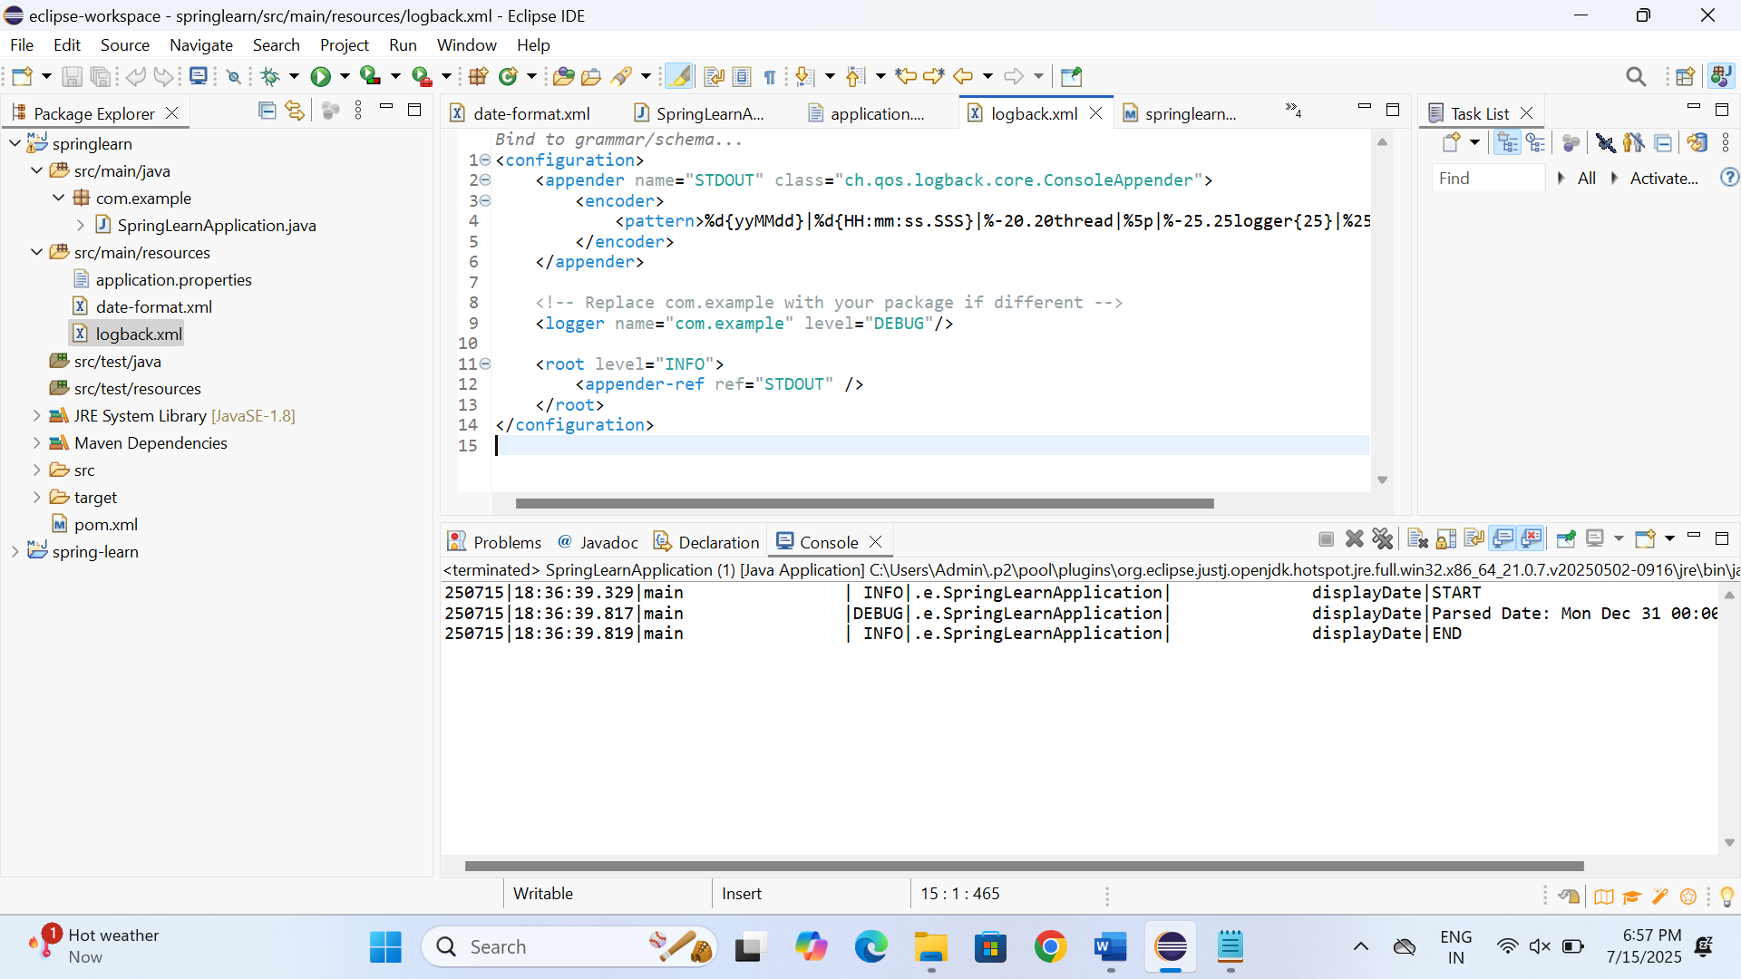

* **Hands on 4 => Spring Core – Load Country from Spring Configuration XML**

**Pom.xml**

<project xmlns="http://maven.apache.org/POM/4.0.0"

xmlns:xsi="http://www.w3.org/2001/XMLSchema-instance"

xsi:schemaLocation="http://maven.apache.org/POM/4.0.0

http://maven.apache.org/xsd/maven-4.0.0.xsd">

<modelVersion>4.0.0</modelVersion>

<groupId>com.example</groupId>

<artifactId>spring-learn</artifactId>

<version>1.0-SNAPSHOT</version>

<properties>

<maven.compiler.source>1.8</maven.compiler.source>

<maven.compiler.target>1.8</maven.compiler.target>

</properties>

<dependencies>

<!-- Spring Core and Context for ApplicationContext and XML Config -->

<dependency>

<groupId>org.springframework</groupId>

<artifactId>spring-context</artifactId>

<version>5.3.30</version>

</dependency>

<!-- SLF4J API (Logger, LoggerFactory) -->

<dependency>

<groupId>org.slf4j</groupId>

<artifactId>slf4j-api</artifactId>

<version>1.7.36</version>

</dependency>

<!-- SLF4J Simple implementation to print logs to console -->

<dependency>

<groupId>org.slf4j</groupId>

<artifactId>slf4j-api</artifactId>

<version>1.7.36</version>

</dependency>

<dependency>

<groupId>ch.qos.logback</groupId>

<artifactId>logback-classic</artifactId>

<version>1.2.11</version>

</dependency>

</dependencies>

</project>

**Country.java**

package com.example;

import org.slf4j.Logger;

import org.slf4j.LoggerFactory;

public class Country {

private static final Logger *LOGGER* = LoggerFactory.*getLogger*(Country.class);

private String code;

private String name;

public Country() {

*LOGGER*.debug("Inside Country Constructor");

}

public String getCode() {

*LOGGER*.debug("Inside getCode()");

return code;

}

public void setCode(String code) {

*LOGGER*.debug("Inside setCode()");

this.code = code;

}

public String getName() {

*LOGGER*.debug("Inside getName()");

return name;

}

public void setName(String name) {

*LOGGER*.debug("Inside setName()");

this.name = name;

}

@Override

public String toString() {

return "Country [code=" + code + ", name=" + name + "]";

}

}

**SpringLearnApplication.java**

package com.example;

import org.slf4j.Logger;

import org.slf4j.LoggerFactory;

import org.springframework.context.ApplicationContext;

import org.springframework.context.support.ClassPathXmlApplicationContext;

import com.example.*;

public class SpringLearnApplication {

private static final Logger *LOGGER* = LoggerFactory.*getLogger*(SpringLearnApplication.class);

private static ApplicationContext *context*;

public static void main(String[] args) {

*displayCountry*();

}

public static void displayCountry() {

*LOGGER*.info("START");

*context* = new ClassPathXmlApplicationContext("country.xml");

Country country = *context*.getBean("country", Country.class);

*LOGGER*.debug("Country : {}", country.toString());

*LOGGER*.info("END");

}

}

**Country.xml**

<?xml version="1.0" encoding="UTF-8"?>

<beans xmlns="http://www.springframework.org/schema/beans"

xmlns:xsi="http://www.w3.org/2001/XMLSchema-instance"

xsi:schemaLocation="http://www.springframework.org/schema/beans

https://www.springframework.org/schema/beans/spring-beans.xsd">

<bean id="country" class="com.example.Country">

<property name="code" value="IN" />

<property name="name" value="India" />

</bean>

</beans>

**Output**

